**DAA – Assignment no: 05**

Write a Python Program to Design n-Queens matrix having first Queen placed. Use backtracking to place remaining Queens to generate the final n-queen’s matrix.

Input:

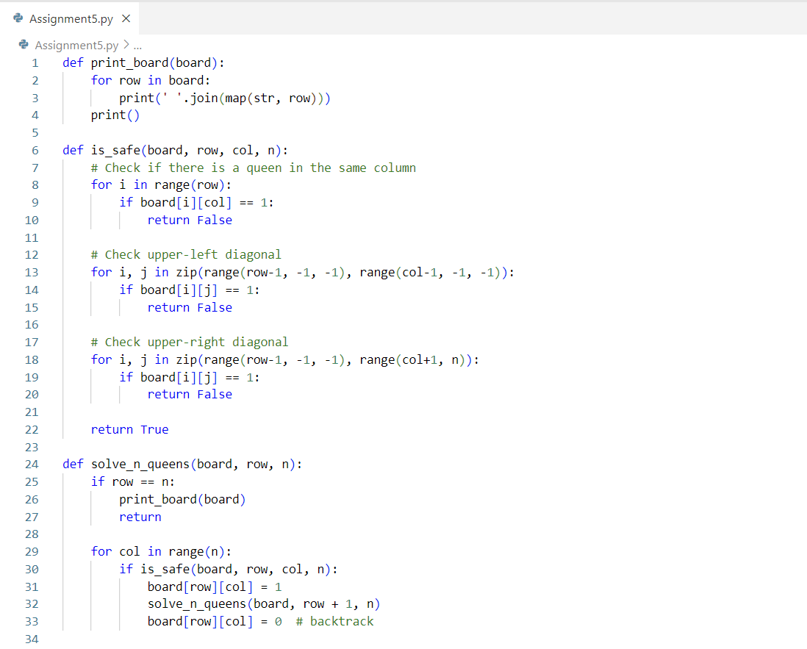

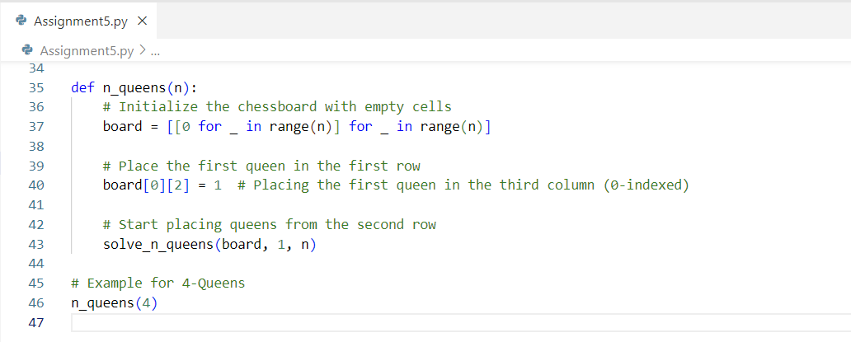

Output:

